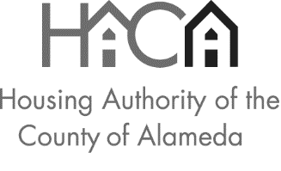
Tel. 510.538.8876 TDD 510.727.8551 Fax 510.537.8236 www.haca.net

HACA PBV OWNER/DEVELOPER PROPOSAL
ADDENDUM #1

EXISTING HOUSING PROPOSALS

All HACA PBV OWNER/DEVELOPER PROPOSALs for Existing projects submitted through this Request for Proposals (RFP) will not be scored on the following Factors for Scoring and Ranking Proposals on the Factors for Scoring & Ranking tab of the application:

E. Project Financing and Local Government Support
G. Project Readiness

The Total Possible Points for Existing projects will be 85.

Additionally, for Existing project proposals submitted through this RFP, the Minimum Points Required will be 60.

NEW CONSTRUCTION PROPOSALS

All HACA PBV OWNER/DEVELOPER PROPOSALs for New Construction projects submitted through this Request for Proposals (RFP) will continue to be scored on all Factors for Scoring & Ranking as originally listed in the RFP.

Additionally, for New Construction project proposals submitted through this RFP, the Minimum Points Required will continue to be 100.

